Test Case: tc001_SPX_Dev5_Crear_Requisicion_Spot_Tipo_Cobro_CC
Step 1 - Enter username and password and click to button Enter : Credentials Entered
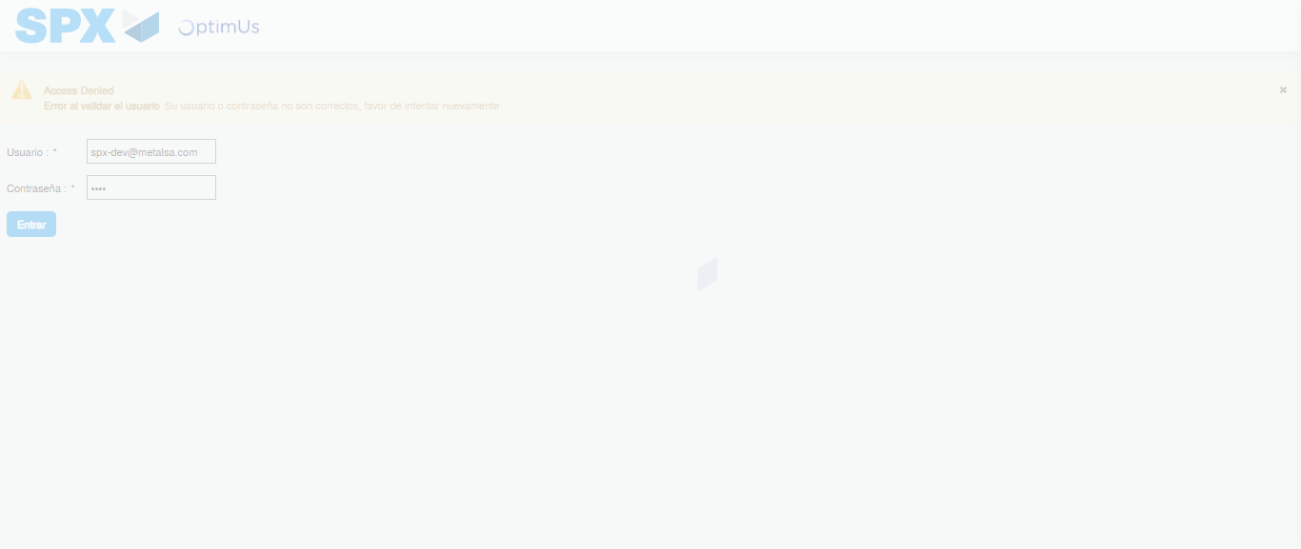Image file-name: QC_Testing-tc001_SPX_Dev5_Crear_Requisicion_Spot_Tipo_Cobro_CC-1789482749034

Step 2 - Select to UEN and Access to Spot Buy Requisitions : UEN Correctly selected and Correct access
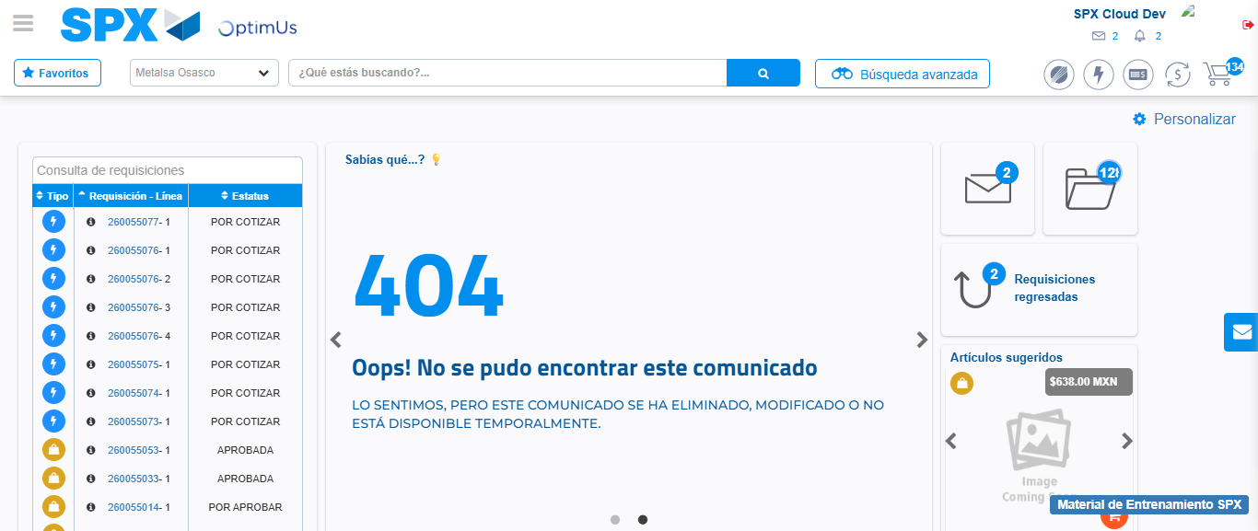Image file-name: QC_Testing-tc001_SPX_Dev5_Crear_Requisicion_Spot_Tipo_Cobro_CC-1789482772804

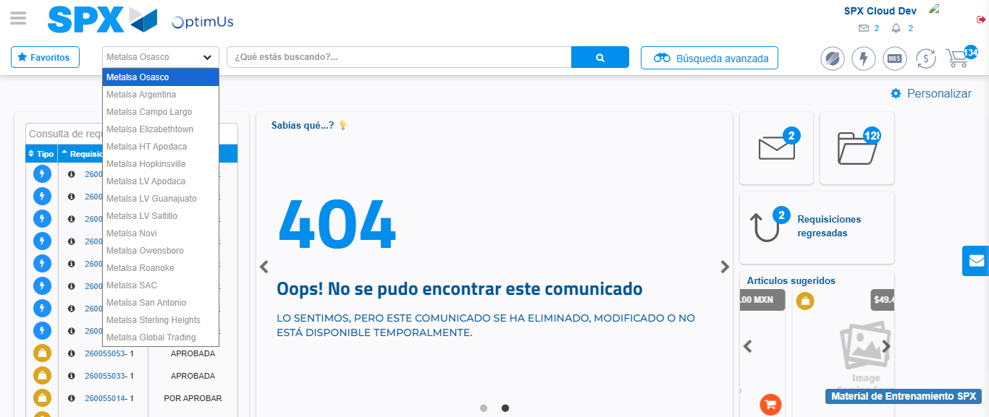Image file-name: QC_Testing-tc001_SPX_Dev5_Crear_Requisicion_Spot_Tipo_Cobro_CC-1789482773555

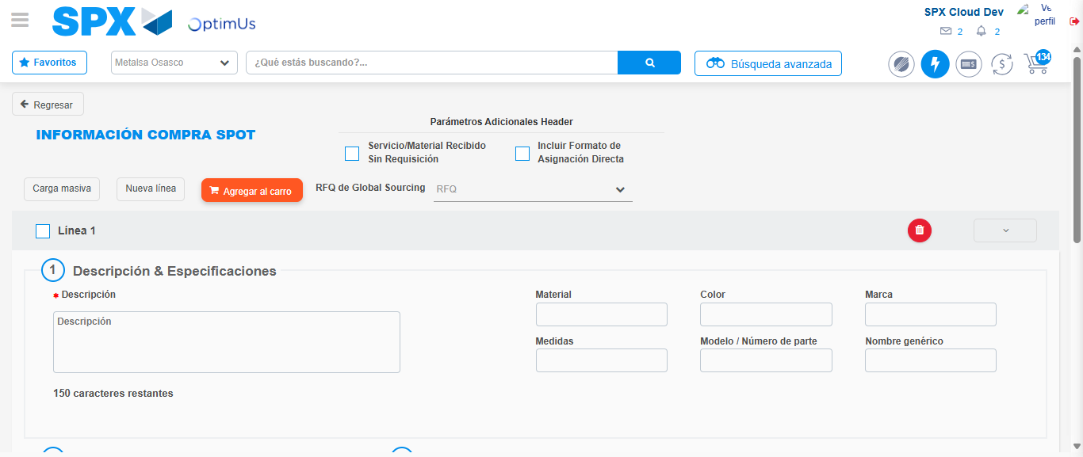Image file-name: QC_Testing-tc001_SPX_Dev5_Crear_Requisicion_Spot_Tipo_Cobro_CC-1789482778432

Step 3 - Data Capture Spot Buy Requisition : Data captured correctly
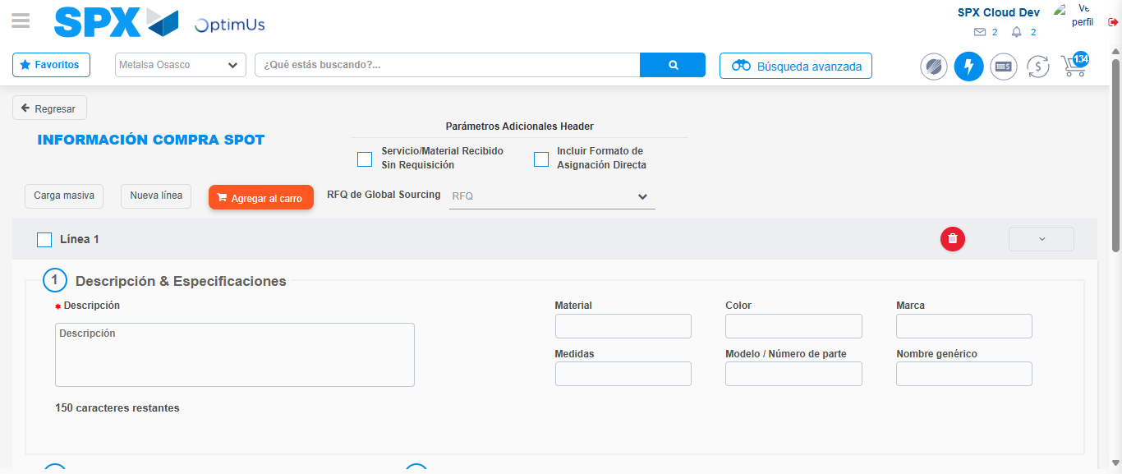Image file-name: QC_Testing-tc001_SPX_Dev5_Crear_Requisicion_Spot_Tipo_Cobro_CC-1789482778686

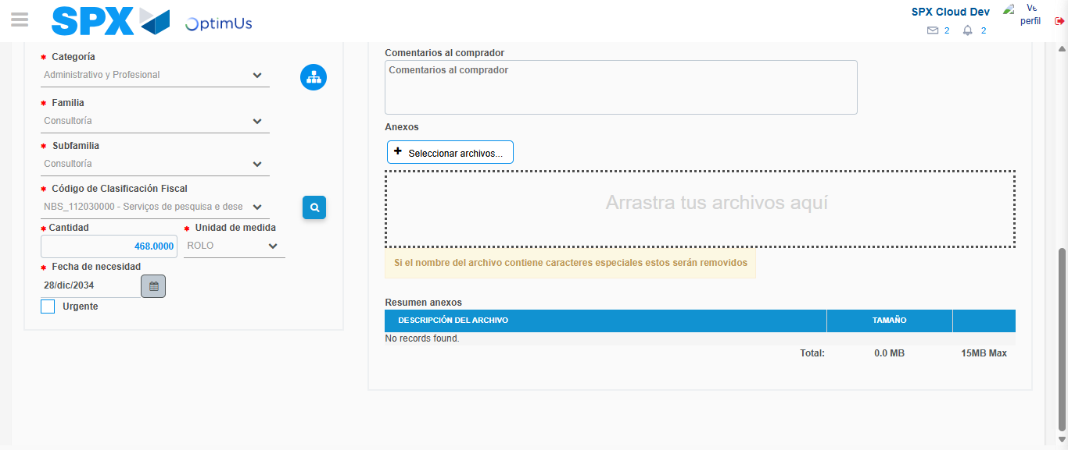Image file-name: QC_Testing-tc001_SPX_Dev5_Crear_Requisicion_Spot_Tipo_Cobro_CC-1789482794449

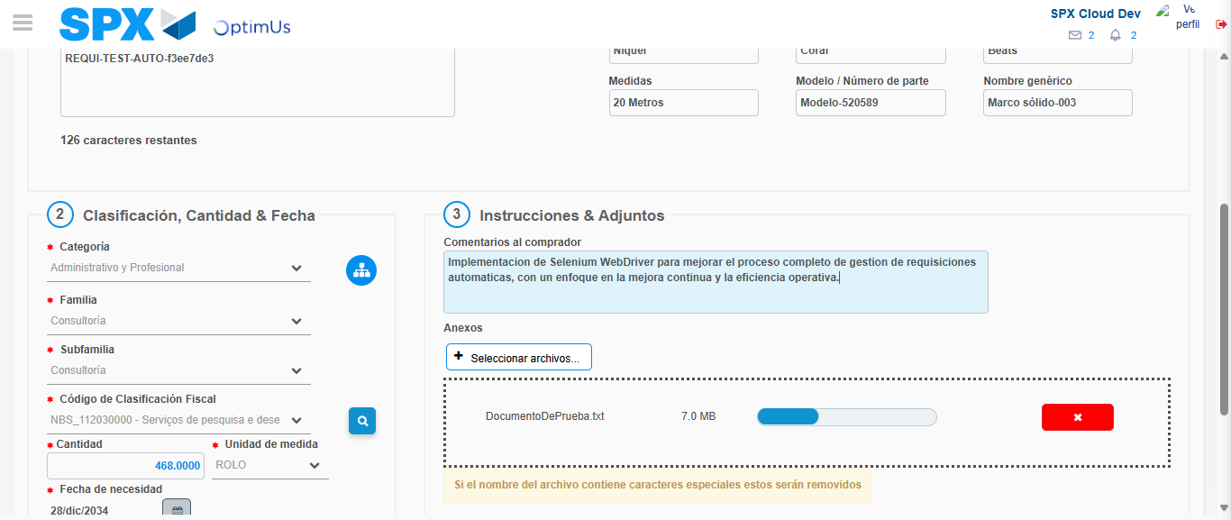Image file-name: QC_Testing-tc001_SPX_Dev5_Crear_Requisicion_Spot_Tipo_Cobro_CC-1789482795386

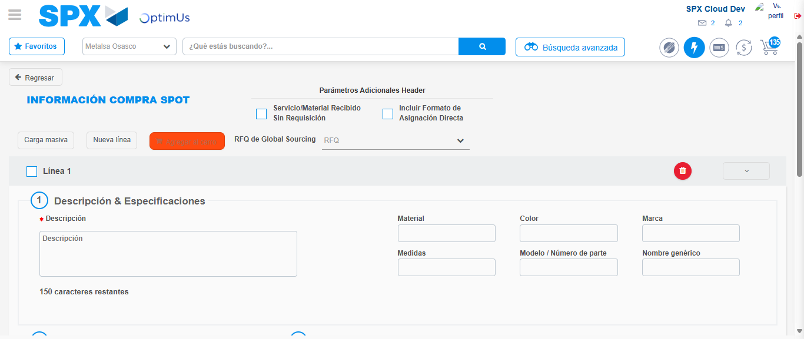Image file-name: QC_Testing-tc001_SPX_Dev5_Crear_Requisicion_Spot_Tipo_Cobro_CC-1789482796872

Step 7 - Return to Main Page SPX : Return to Main Page SPX
Image file-name: QC_Testing-tc001_SPX_Dev5_Crear_Requisicion_Spot_Tipo_Cobro_CC-1789482772804

Image file-name: QC_Testing-tc001_SPX_Dev5_Crear_Requisicion_Spot_Tipo_Cobro_CC-1789482773555

Image file-name: QC_Testing-tc001_SPX_Dev5_Crear_Requisicion_Spot_Tipo_Cobro_CC-1789482778432

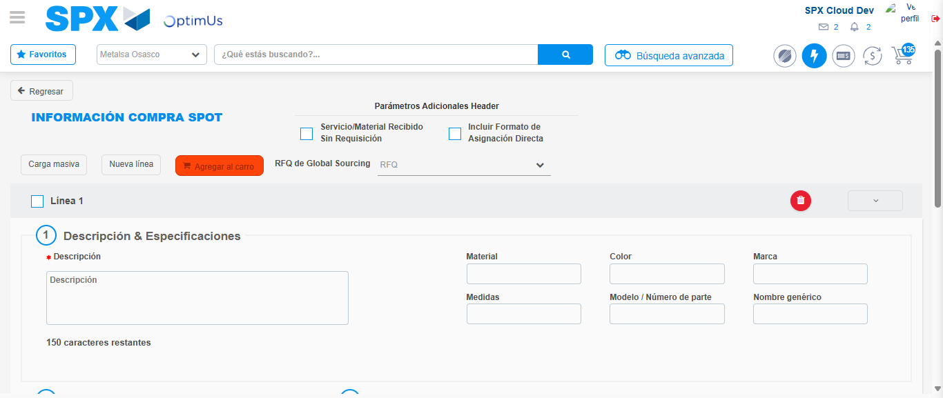Image file-name: QC_Testing-tc001_SPX_Dev5_Crear_Requisicion_Spot_Tipo_Cobro_CC-1789482799144

Image file-name: QC_Testing-tc001_SPX_Dev5_Crear_Requisicion_Spot_Tipo_Cobro_CC-1789482799328

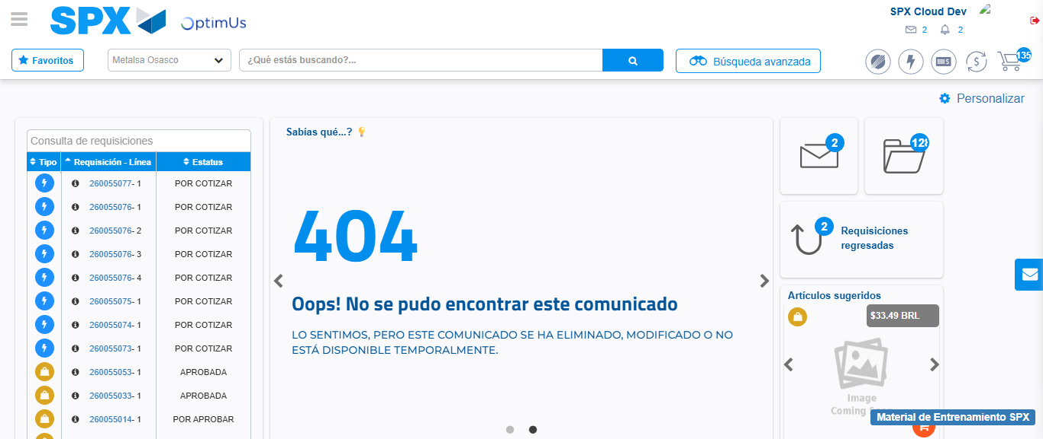Image file-name: QC_Testing-tc001_SPX_Dev5_Crear_Requisicion_Spot_Tipo_Cobro_CC-1789482820375

Step 8 - Log Out : Log Out SPX
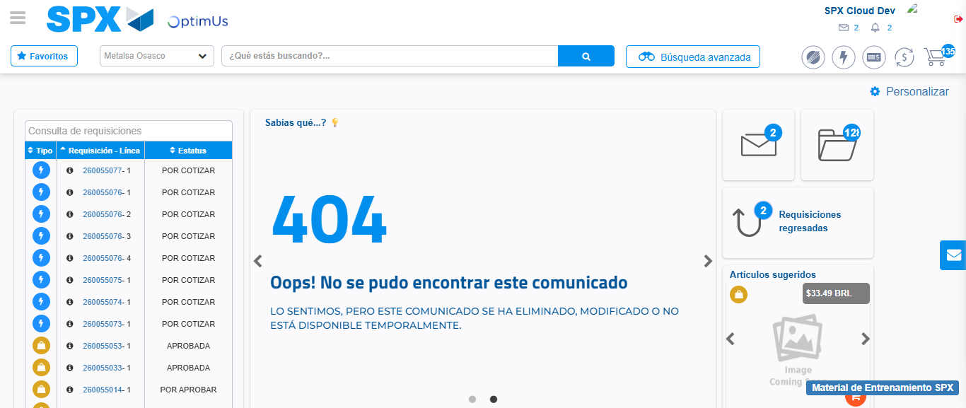Image file-name: QC_Testing-tc001_SPX_Dev5_Crear_Requisicion_Spot_Tipo_Cobro_CC-1789482820692

